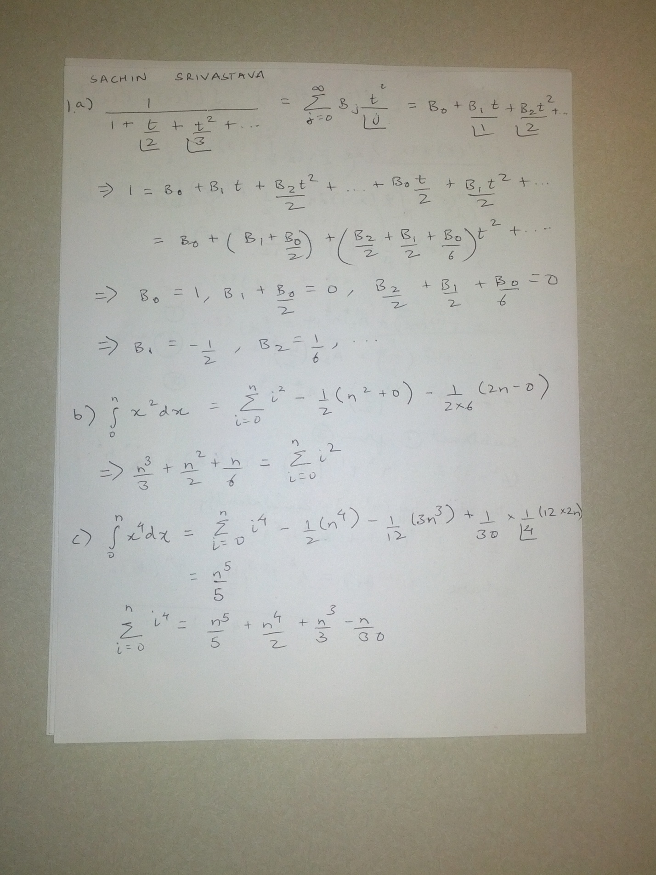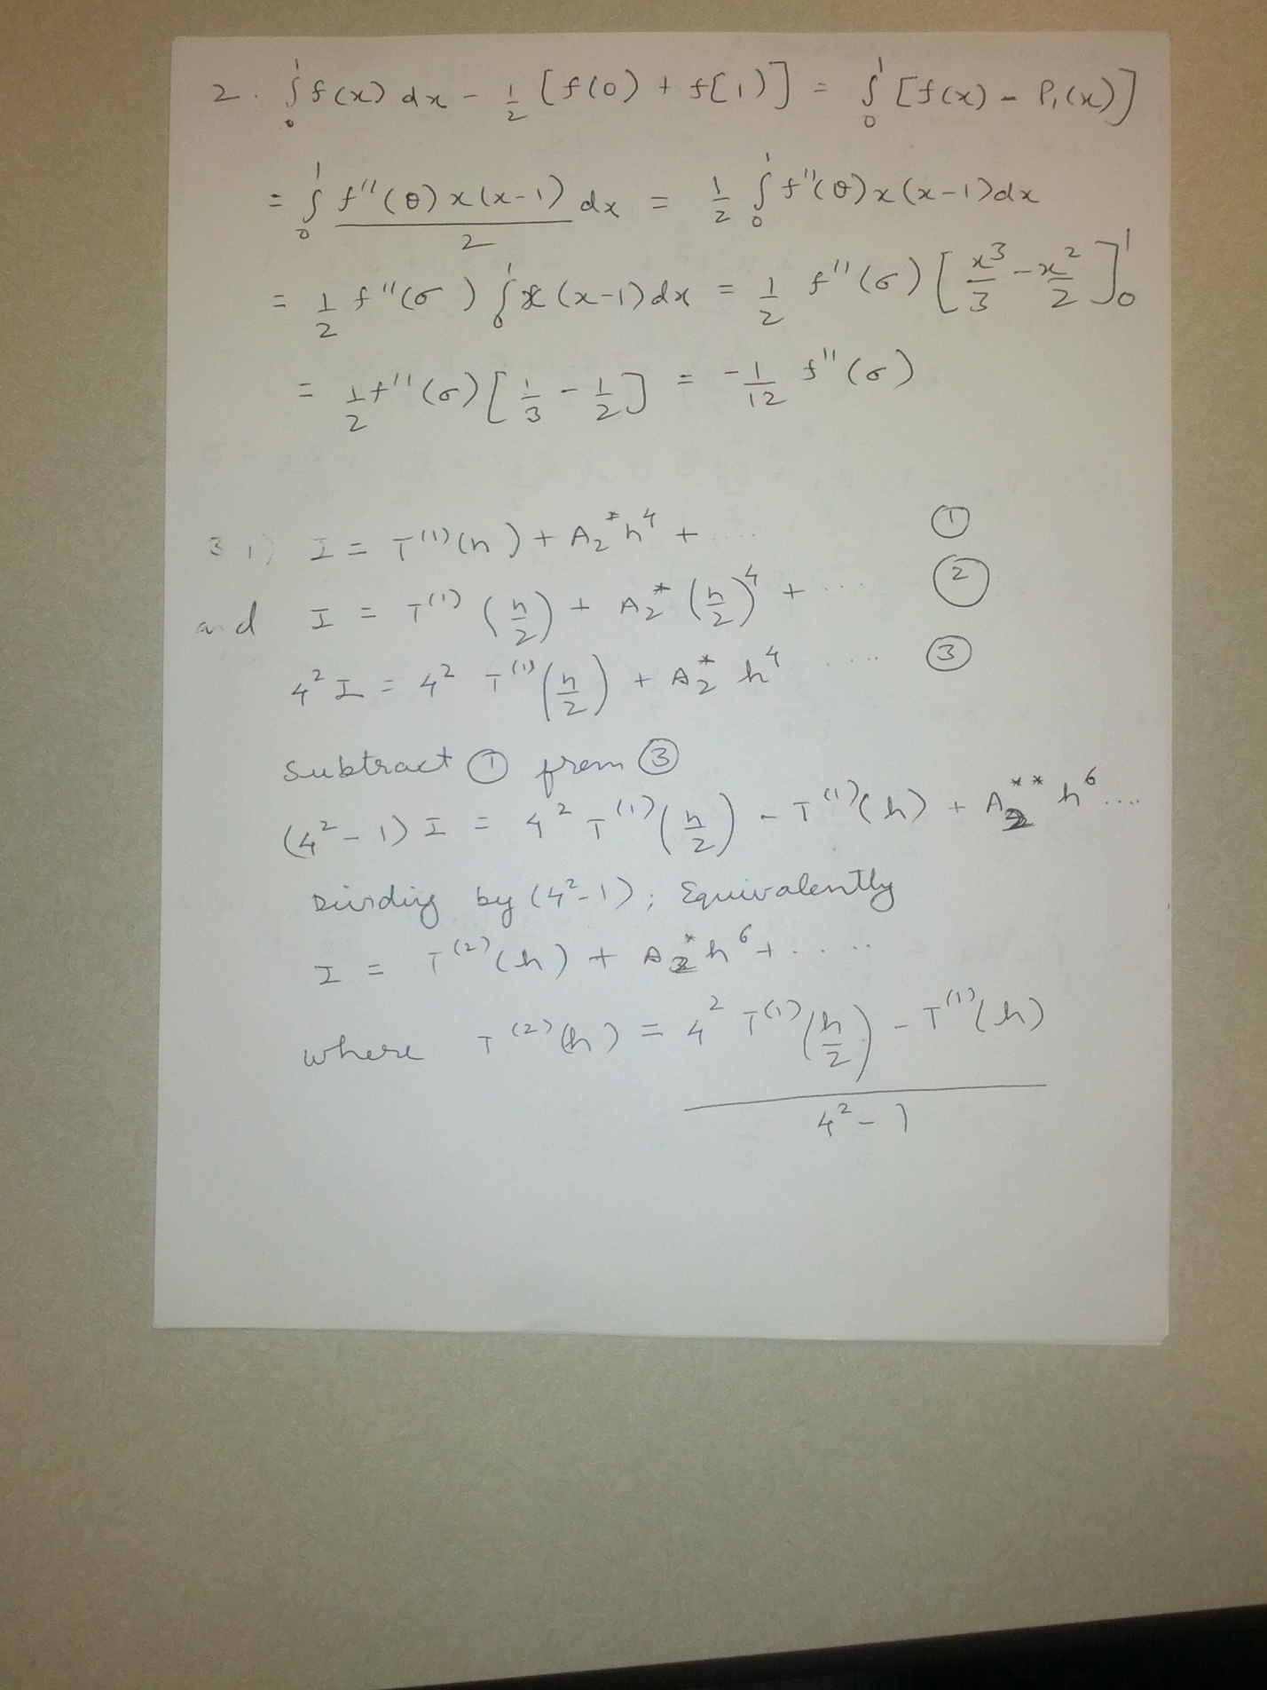3. iii)

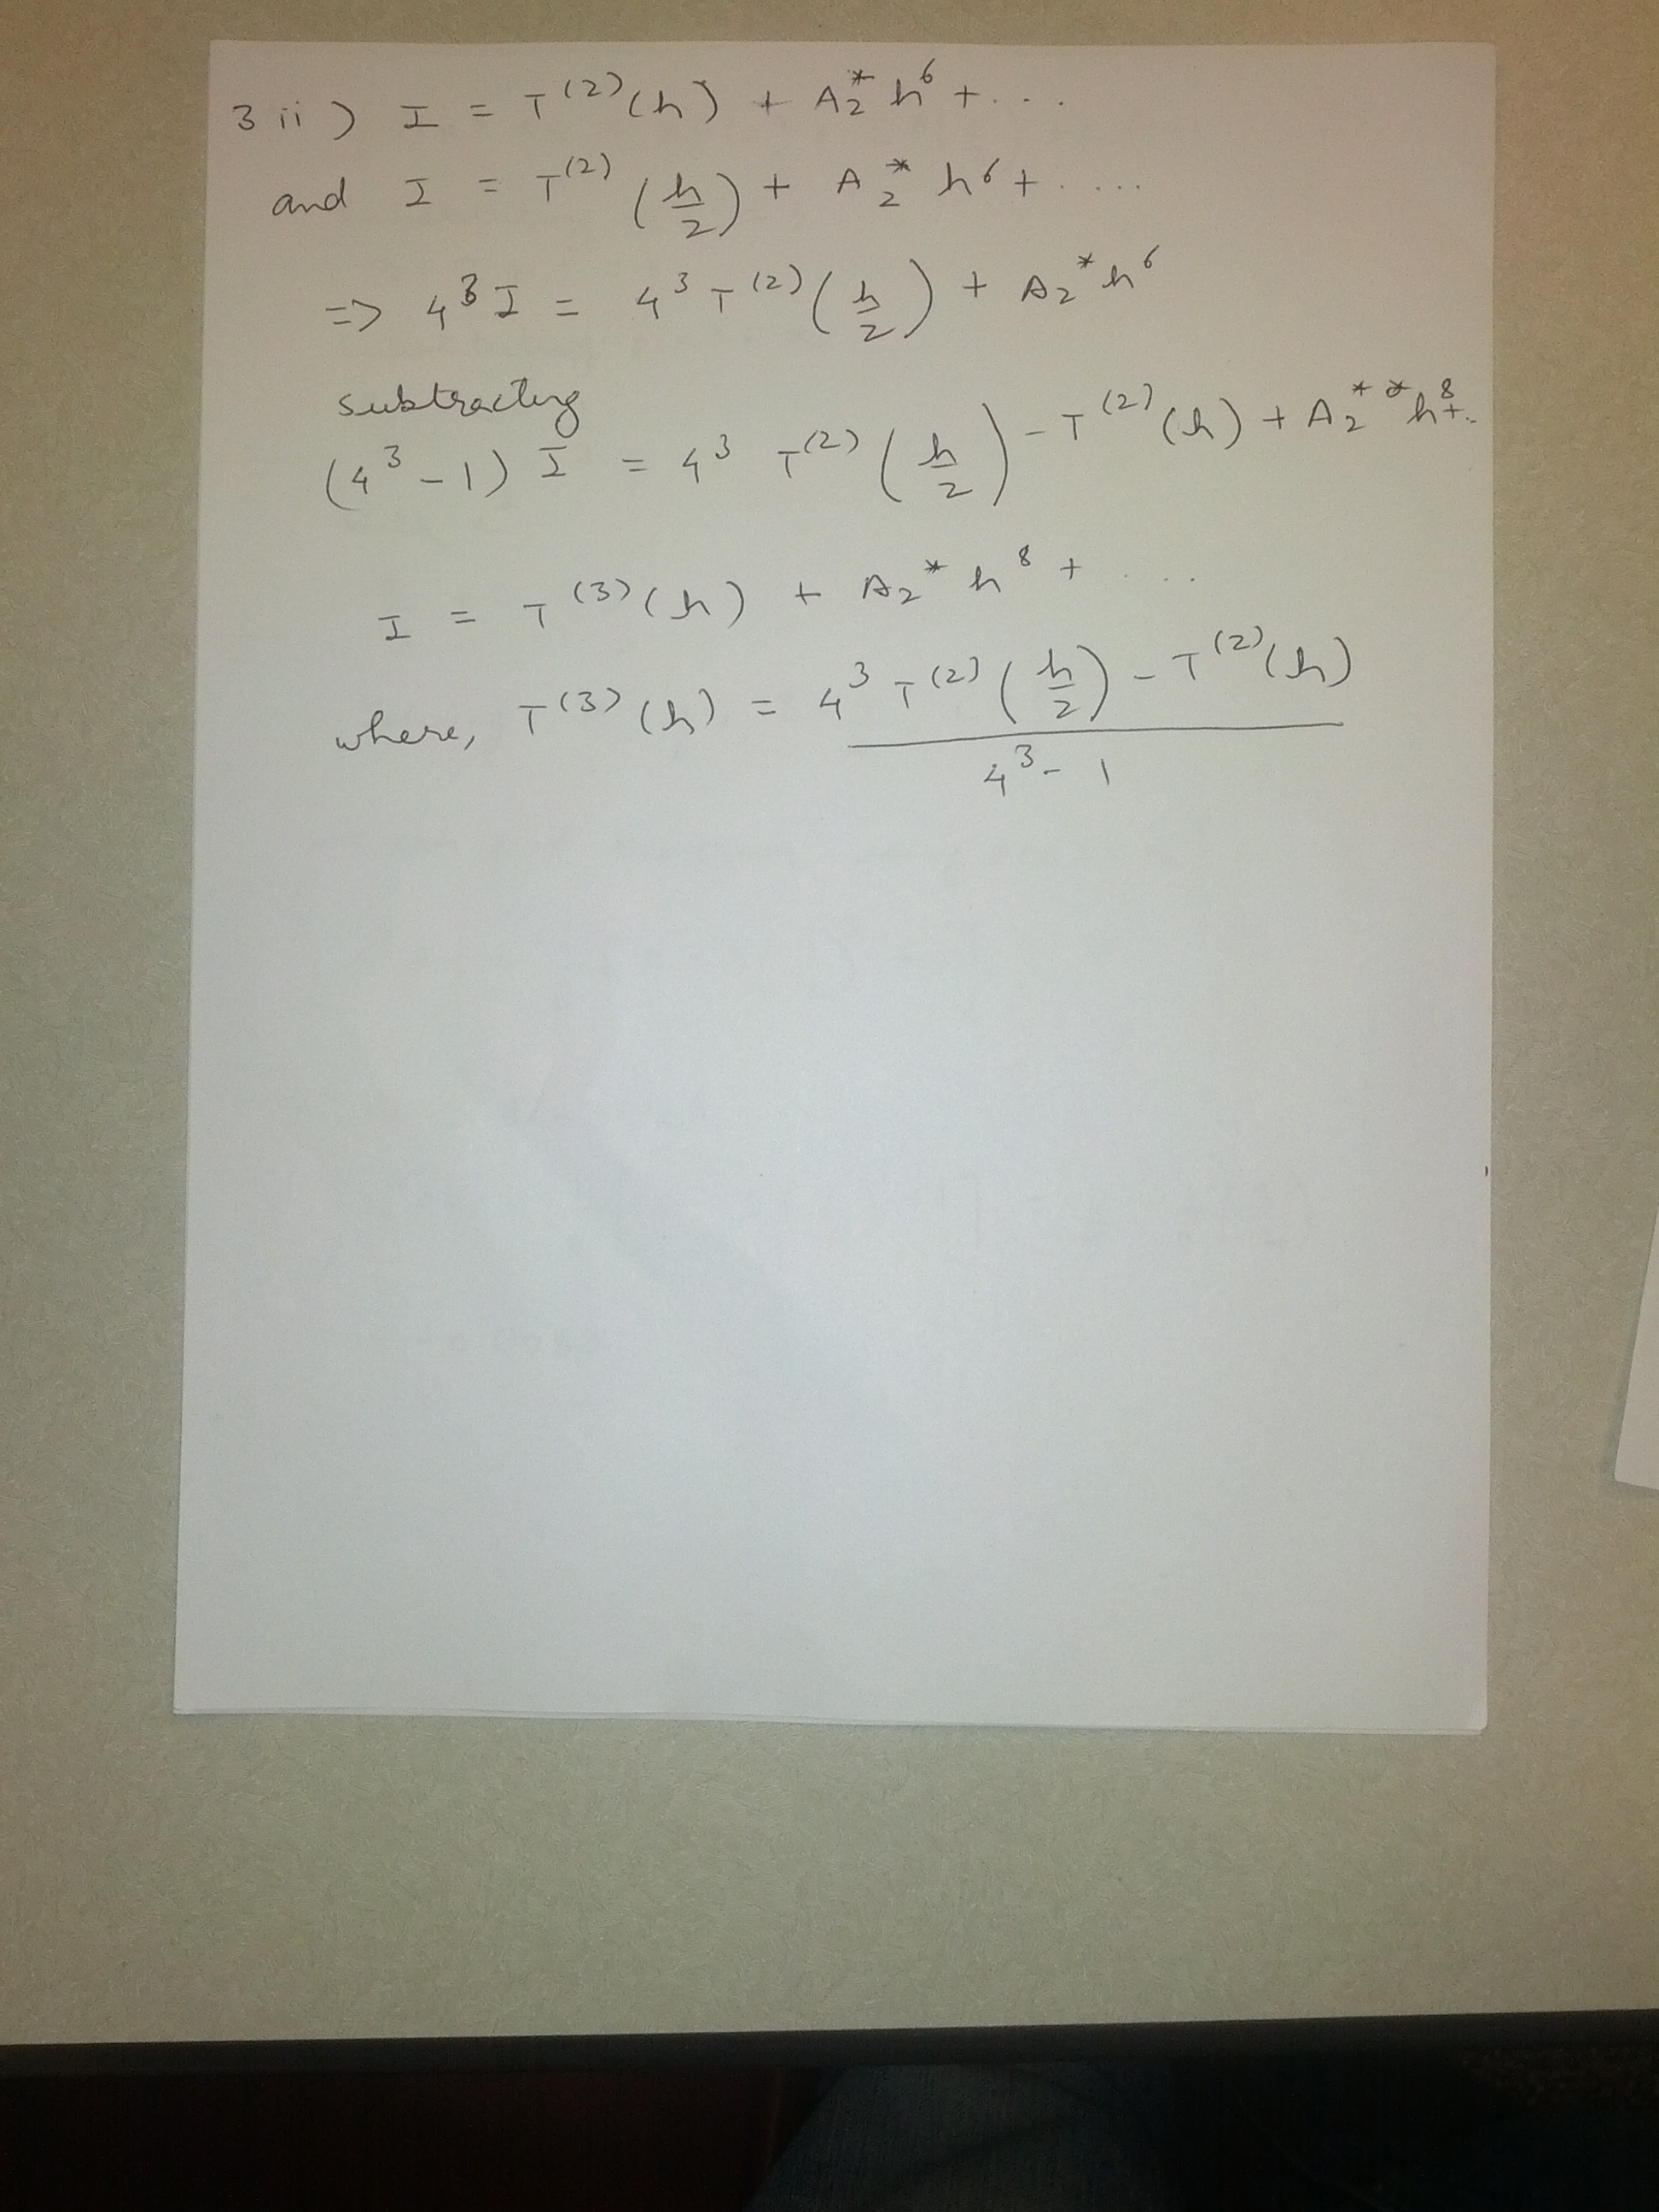

function integral=trapezoidal(a,b,h,index_f)

n=(b-a)/h;

Midtem-2 practice-with solutions

sumend = (f(a,index_f) +f(b,index_f))/2;

sum = 0;

for i=1:1:n-1

sum = sum + f(a+i*h,index_f);

end

integral = h*(sumend + sum);

function f_value = f(x,index)

switch index

case 1

f_value = x;

case 2

f_value = x^7;

end

3. iv)

|  |  |  |  |
| --- | --- | --- | --- |
| O(h^2 ) | O(h^4 ) | O(h^6 ) | O(h^8 ) |

0.500000000000000

0.253906250000000 0.171875000000000

0.160339355468750 0.129150390625000 0.126302083333333

0.134043693542480 0.125278472900390 0.125020345052083 0.125000000000000=1/8

